OPENING
Attendees: Michael W, Chad R, Jim P, Scott C, Kramer G, Brett B, Andy G, Nathan W, Scott S, Morgan M, Gene B, Brian C & Nick C

Call to Order - President
Bring this meeting to order at 11:00 a.m.
Confirm Quorum – quorum achieved.

Approval of Previous Meeting(s)’s Minutes
Approval of Meeting Minutes from September. No minutes to approve from October as no official meeting held due to lack of quorum.
Any discussion or changes to the minutes? None
Those who approve the minutes? Unanimous

Welcoming of Invited Guest(s)

BODY OF MEETING – High Priority Items (Round 1)

Treasurer’s Updates
- Treasurer’s Updates
- ◊ Bank Balance (as of 15 Nov 2019)
- o Per Website: $5,082.86
- o Per Ledger: $4,930.97

- ◊ Iowa Leather Weekend
- o Food Sales $520.00
- o Vendor Mart Sales $330.00
- o Shot Sales $195.00
- o Clothes Check $385.00
- o Gross Profit $1,430.00
- o Expenses $1,215.23
- o Net Profit $214.77

- ◊ Budget Updates
- o ILW 2019 Marketing
- ▪ Budgeted $115.00
- ▪ Spent $99.50
- ▪ Remainder $15.50
- o ILW 2019 Food
- ▪ Budgeted $175.00
- ▪ Spent $112.56
- ▪ Remainder $62.44
- o ILW 2019 Cocktail Supplies
- ▪ Budgeted $130.00
- ▪ Spent $102.67
- ▪ Remainder $27.33
- o Treasurer’s Supplies
- ▪ Budgeted $50.00
- ▪ Spent $45.86
- ▪ Remainder $4.14
- o Equipment
- ▪ Budgeted $55.00
- ▪ Spent $52.43
- ▪ Remainder $2.57
Clarification on liquor for shot sales. Scott will double check budget vs spent on shot sales.
$61 was raised at October shot sales.

President's Updates

- Elections coming up at the February Planning Meeting
  - for President, Secretary, Sports League Chair, Bylaws Chair, Social Media Admin Chair, and Iowa Leather Weekend Chair.

- Volunteer Hours Update
  - Numbers from Morgan. Chad will email rep members so we know where we stand. Only a few close to 20 volunteer hours. Annual membership through the end of February.

- Annual Membership Reminder coming up.

President's Updates

- Bylaws Revision Proposal – 1st Reading

- Current
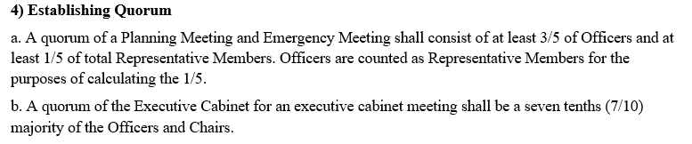

- Proposed
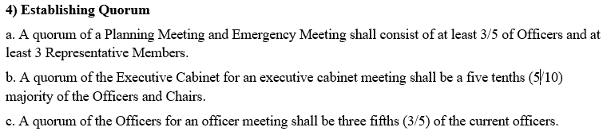
Explanation of memberships and needs; Explanation of what the cabinet is; Discussion of above numbers.

Re-word to 6/10 for quorum for chairs.

Current
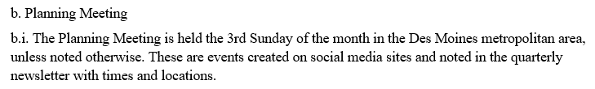

Proposed
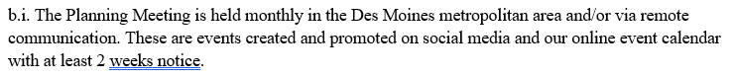
Discussion to remove wording that will be less specific. Discussion about social media vs website and google calendar. These things don’t need to be in bylaws but can be in SOP’s

Current
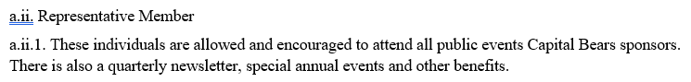

Proposed
Change text to “There are also special annual events.”

Current
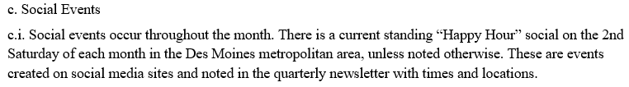

Proposed
ADD: And online event calendar

Current
a.iii. Dues
a.iii.1 Membership fees for the representative membership will be due annually by March 1st and shall consist of $30
a.iii.2. A member’s first year dues shall be prorated depending on the month of registration.
a.iii.2.a.i February, march, April, May = $30
a..iii.2.a.ii June, July, August, September = $20
a.iii.2.a.iii October, November, December, January = $10
a.iii.3 A member may qualify for a discounted membership if they have volunteered at least 20 hours for events in the previous 12 month period of March 1st through the last day of February. With this condition met, the fee for the following yer will be $10

Proposed
Remove current dues from bylaws and add to the SOP’s.

Discussion as to the status of our SOP’s. We don’t have a published/master SOP. If we make changes to SOP we should be voting? We do have to submit the bylaws to the Sec of State for our 501c3 status. We have incorporated but haven’t received 501c3 status.

- Pride center donation. How much should we donate? $120 for now.
  - Motion to donate $120 to the Pride Center for the year 2019 – 2020 fiscal year ending February 29, 2020we have been using the facility
  - Moved by Brian C, Second by Scott S.
  - Discussion as to why $120. $10/month
  - Call to question: Motion passes

- Conversation with Skyler Hoth of the Iowa Wolves. Pride night on February 10, 2020.
  - Discussion as to this event: ½ of game ticket sales will be donated to a Domestic Violence organization. LGTBQ+ organizations could have an opportunity to gather and possibly have access to a table to distribute information and possible merchandise. More information will come as we work more with Mr. Hoth.

Vice President’s Updates
- None

Secretary’s Updates
- None

Social Officer’s Updates
- November happy hour. Shot sales revenue will go towards the holiday gift donation.
No motion needed

- December 7th is the holiday party. We’ll also raise money to go towards holiday gift donation.

- Ask for another $700 for the holiday party
  - Motion to add another $700 for the holiday party budget
  - Motion by Chad R, Moved by Scott, Second by Jim P
  - Discussion as to who will cater. Smokey D’s? Brian C suggests to spend the money as this is a large event and brings in members. It’s a good value.
Motion passes

- Holiday family gifts. Up to $750. Gifts have to be delivered by December 16th. We’ll Spend the $750? However, money raised from November happy hour and holiday party will offset the costs.
  - Motion to spend up to $750 for holiday gifts to donate to family
  - Motion to spend up to $750 for holiday gifts, second by Brian C.
  - Discussion: number of families? 1 to 3. Passing the hat and raising money at happy hour as well as the Bear Holiday party will go towards the $750 and the Bears will make up the remainder.
  - Jim P reminded us If we were a 501c3 we can use that to get donations from businesses for this. Clarification that we are not yet.
  - Call to question: motion passes

- January membership party January 23, 2020
Club G pricing went up
Looking at possibly bowling at Merle Hay Lanes which will cost approx $15 per person
- Motion to spend up to $500 for membership party
- Second by Brian C
- Motion passes
Discussion to have the event note those who are bowling and those who will not be bowling but will attend. We don’t want to pay for an attendee who doesn’t bowl.

Up coming expenses and events
- February Happy Hour Shot sales
- Party at NAB
- NAB Van
- Bear Necessities
- March Happy Hour

Bear Necessities Chair Updates
- Budget of $3,000 (no other information provided to the Secretary before publishing the agenda) More information will be provided at the planning meeting.
- No other information provided at planning meeting.
  - Motion to pass a budget of up to $3,000 for Bear Necessities. Ticket sales will offset this cost and the Capital Bears will be responsible for the difference.
  - Motion fails due to no Second
  - Chad R. motions to budget $1,500 for Bear Necessities plus ticket sales revenue to Bear Necessities.
  - Second by Trevor
  - No discussion
  - Motion passes

Capital City Pride Chair’s Updates
- None

Pride Sport League Chair’s Updates
- None

Social Media Administrator’s Updates
- None

Bylaws Chair’s Updates
- None

Iowa Leather Weekend Chair’s Updates
- None

Merchandise & Marketing Chair’s Updates
- None

BODY OF MEETING – Lower Priority Items (Round 2)

President's Updates
- December 15th planning meeting do brunch at Gilroy’s at 9:30 a.m. 11:00 a.m. meeting and gift wrapping at the Pride Center

Vice President’s Updates
- None

Treasurer’s Updates
- None

Secretary’s Updates
- None

Social Officer’s Updates
- None

Bear Necessities Update
- None

Capital City Pride Chair’s Updates
- None

Pride Sport League Chair’s Updates
- None

Social Media Administrator’s Updates
- None

Bylaws Chair’s Updates
- None

Iowa Leather Weekend Chair’s Updates
- None

Merchandise & Marketing Chair’s Updates
- None

OPEN DISCUSSION (Round 3)

UPCOMING PLANNING MEETINGS, EVENTS, AND OTHER DATES OF NOTE

- Nov 17 – Planning Meeting
- Dec 7 – Holiday Party – at Chad and Brian’s
- Dec 14 – Bear Happy Hour - Christmas Carol Karaoke
- Dec 15 – Planning Meeting
- Jan 11 – Happy Hour
- Jan 18 – Planning Meeting
- Jan 23 – Rep Member Party
- Feb 2 – Election and Planning Meeting
- Feb 8 – Happy Hour – Mr Iowa Bear Sendoff Fundraiser
- Feb 10 – Iowa Wolves Pride Night
- Feb 13-16 – NAB

Motion to Adjourn at 12:00
MEETING ADJOURNED

